EPPING FOREST LIBERAL DEMOCRATS
CONSTITUENCY PROFILE FOR EPPING FOREST DISTRICT
Epping Forest District is a mixture of rural and urban areas and stretches northwards from its boundary with Greater London into the heart of rural Essex. The key population centres are the commuter towns of Loughton, Chigwell, Buckhurst Hill and Epping which are served by the Central Line together with Ongar which is no longer connected by rail. Heavily populated Waltham Abbey is close to a mainline railway which runs south to London. The M11 and M25 run through the area providing good motor transport links and the A414 is a main artery linking the East and West to the north of the District. However, in the rural areas there are accessibility issues for those without private transport especially in the outlying villages.
The 2021 Census found the population was 135,000 with 54,600 households, an increase of 8% over the numbers from the previous decade. The population density at 398 per square kilometre is approximately the same as the rest of the East of England. The Census showed a 16% increase in the over 65 age group representing a relatively aging population which is exacerbated by the high cost of housing in the District. The Local Plan makes provision for the housing stock to increase by 11,400 over the next decade. There will be substantial development around Harlow and North Weald Bassett plus significant additions in Waltham Abbey and Epping.
Over 80% of the District is classified as Green Belt. Epping Forest itself is a unique and ancient woodland of some 6,000 acres, owned by and managed by the Corporation of London and lying in the centre of the constituency. The Lea Valley Regional Park overlaps the west of the district and further public open space is provided by the Roding Valley Park and Hainault Forest. Places of special interest include the church at Waltham Abbey with its monastic remains; possibly the world’s oldest timber-framed church at Greensted; the former Royal Gunpowder Mills at Waltham Abbey and the historic wartime airfield at North Weald.
There are contrasting patterns of employment in the District with about half the working population in the south commuting to London and more diversity in the rural areas to the north of the M25. The district is highly entrepreneurial with high levels of self-employment and many small and medium enterprises.
Politically, Eleanor Laing (Deputy Speaker) has been the Constituency Member of Parliament for many years. The District Council is Conservative controlled but over the past two years the Liberal Democrat representation has doubled from 3 to 6 when we won three new wards. Previously our three councillors were all in Epping Hemnall, a Lib Dem ward for many years. Following the LG Boundary Commission's recent review Epping Forest has all out elections in May 2024 and all the wards become three member wards and larger.
Download the Boundary Commission map with link www.lgbce.org.uk/sites/default/files/2023-07/si_2023-819_-_epping_forest_electoral_changes_order_map.pdf

Political Change 2019-2023

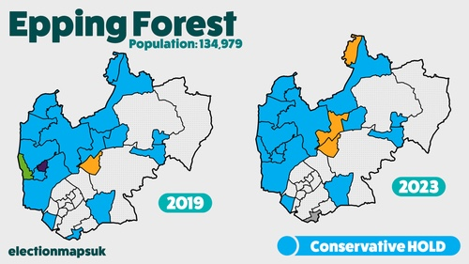

END August 2023

